PROJECT REPORT

ON

SMART RESTAURANT BOT
(BUILT AS PART OF REQUIREMNTS OF GURUCOOL PROGRAM BY SMART INTERNZ)

SUBMITTED BY

NEENA AJ

ASSISTANT PROFESSOR

DEPARTMENT OF ECE

COLLEGE OF ENGINEERING KIDANGOOR

KOTTAYAM

neenaaj@ce-kgr.og

ACKNOWLEDGEMENT
Foremost I would like to thank the Smart Internz team in partnership with IBM for conducting this national faculty program, thereby giving us exposure to the fields of artificial intelligence, machine learning and internet of things.
I wholeheartedly thank the resource persons for efficiently handling the in depth and extensive online classes on all the 6 days, which helped us familiarize the technologies.
I would also thank our mentor Mr Hemanth Kumar, for his guidance and support throughout the completion of this project.

CONTENTS
1 INTRODUCTION---------------------------------------------------------------------------------------------------- 03
2 LITERATURE SURVEY-------------------------------------------------------------------------------------------- 04-
3. BLOCK DIAGRAM & EXPLANATION-------------------------------------------------------------------------- 05
4.FLOWCHART 08
5.RESULT 10
6.CONCLUSION & FUTURE SCOPE 18
APPENDIX
A.SOURCE CODE

CHAPTER 1

INTRODUCTION
Artificial intelligence is on its way to a faster human lifestyle in an efficient way. Virtual bots have become handy nowadays by supporting various domains for smooth lives.Chatbots are helping many sectors by providing services in the form of information agents by effectively accomplishing tasks.
In this project, we develop an end to end mobile application capable of managing/placing orders, displaying recommendations, showing the menu, prompting the best deals or collecting the customer feedback using the IBM Watson Assistant. The customer and the order details are stored in the Cloudant DB. Alert is sent when the order is confirmed using the Cloud Messaging. Speech to Text and Text to Speech Services must be used to take the speech input and give out the speech output.
Features
- Using chatbot we can manage users reservations and orders
- We can give food recommendations and display the menu to the users
- We can Promote best deals and offers on that day
- We will store the customer’s details and orders in the database
- Chat will send a notification to customers if the order is confirmed
- The chatbot is also useful in Follow up on customer feedback

Services Used for the project development are:
1. IBM CLOUD/IBM CLOUDANT/Watson Assistant
2. Node-Red APP
3. FAST2SMS service

2. LITERATURE SURVEY
A bot is a program that automatically completes an action based on specific triggers and algorithms. A chatbot is a computer program that is designed to simulate human conversation. Users communicate with these tools using a chat interface or via voice, just like they would converse with another person. Chatbots interpret the words given to them by a person and provide a pre-set answer. Chatbots, like regular applications, have application layers, databases, conversational user interfaces (CUIs) and APIs. There are 3 common kinds of a chatbot available today: Rule-based chatbots: The most straightforward option, these bots simply provide a pre-defined answer to very specific questions. These bots are great for things like qualifying leads or offering customers an interactive FAQ experience Intelligent chatbots: These intelligent bots use machine learning or “ML” to learn from the user’s requests and information. Intellectual bots are trained to understand specific words and phrases that trigger a reply. They teach themselves over time to understand more questions and deliver better answers AI-powered chatbots: These bots combine the benefits of rule-based bots with the power of intellectually independent programs to solve user problems. They can remember the context of conversations and understand user preferences. These bots use a combination of natural language processing, machine learning, and AI to understand customers. Natural language processing helps the interactions between humans and computers to feel more natural

3.BLOCK DIAGRAM & EXPLANATION
Architecture of proposed model for building smart restaurant chat bot is shown below
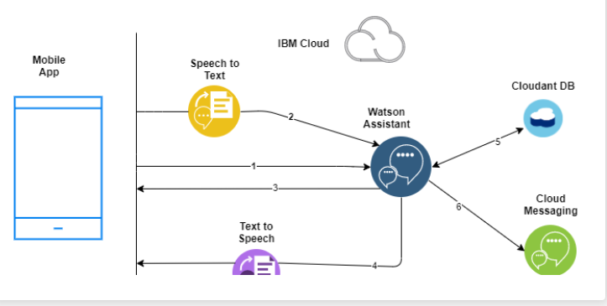

The chatbot developed interprets dialogues, supports several languages and its translations.
The final crucial methodology for chatbots is to use artificial neural networks. These are solutions that give the bots a way to calculate the response to a question using weighted connections and context in data. With artificial neural networks, each sentence provided to a bot is broken down into different words, and each word is used as an input for the neural network. Over time, the neural network becomes stronger and more advanced, helping the bot to create a more accurate set of responses to common queries.
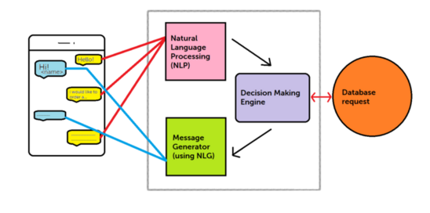

NLU (NATURAL LANGUAGE UNDERSTANDING)
The NLP process is a core part of the chatbot architecture and process, since it is the foundation for translating the natural human language to structured data.
In order for the chatbot to understand the user’s message, it needs to somehow convert the unstructured human language to structured data that computers can interpret. When a user sends a message to the chatbot, it needs to use algorithms to get meaning and context from every sentence to collect data from them. This process is called natural language understanding (NLU), and it’s a subset of natural language processing. It consists of interpreting the user’s message by extracting important and relevant details from it.
A way to extract the essential parts of a sentence is to differentiate between the entities and the intent. An intent of a sentence is the goal of the statement.
The chatbot basically needs to recognize the entities and intents of the user’s messages. In order to do that, we need to build an NLP model for every entity for an intent. For example, we can build an NLP intent model for the chatbot to recognize when a user wants to know the opening hours of a place. We can build an NLP entity model for the chatbot to recognize locations and directions. We can then use these NLP models for the chatbot to offer the opening hours of any place, based on the user’s location.
Intents: It is basically the action chatbot should perform when the user say something. For instance, intent can trigger same thing if user types “I want to order a red pair of shoes”, “Do you have red shoes? I want to order them” or “Show me some red pair of shoes”, all of these user’s text show trigger single command giving users options for Red pair of shoes. Context: When a NLU algorithm analyses a sentence, it does not have the history of the user conversation. It means that if it receives the answer to a question it has just asked, it will not remember the question. For differentiating the phases during the chat conversation, it is state should be stored. It can either be flags like “Ordering Pizza” or parameters like “Restaurant: ‘Dominos’”. With context, you can easily relate intents with no need to know what the previous question was.
Entities: Entity basically represents a concept in your Chatbot. It might be a payment system in your Ecommerce Chatbot.
Context: When a NLU algorithm analyses a sentence, it does not have the history of the user conversation. It means that if it receives the answer to a question it has just asked, it will not remember the question. For differentiating the phases during the chat conversation, it is state should be stored. It can either be flags like “Ordering Pizza” or parameters like “Restaurant: ‘Dominos’”. With context, you can easily relate intents with no need to know what the previous question was.

4.FLOWCHART
The following steps were done to create the chatbot
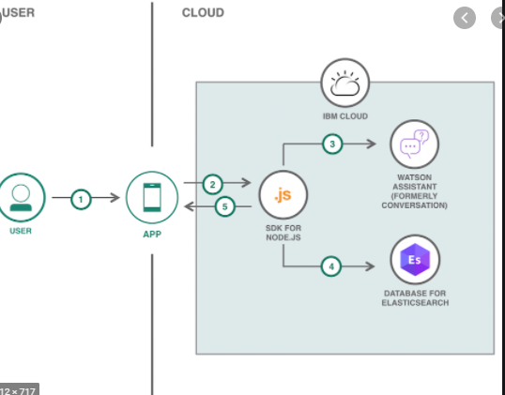
1. Define the purpose.
This is the most important thing to determine for your chatbot. Why are you creating a bot in the first place? If you are taking an existing interaction or process and automating it, what is that current experience like, and how could a bot help the customer or improve the process?
2. Define the goal.
Now that you understand the why, what will this bot do? What is the valuable outcome that a user will gain by interacting with it? It is essential to define your chatbot strategy before the writing begins, so you know exactly what the bot will do and why that goal is important.
3. Outline the steps.
With that end goal, work backward to determine all of the steps necessary to reach that goal. You can likely gain the information from the business website, sales materials, interviews with customers or sales agents, etc.
4. Define the audience and personality.
In order to design an experience that converts, it's crucial to know what the user wants and what their sentiment will be during the interaction. To connect with the audience, you have to know them! How do they buy? What are their challenges? How familiar are they with your topics? These are all questions you will need to answer.
5. Map the flows.
Using the node red app, the flow was created with nodes to integrate with Watson assistant , text to speech and speech to text service and the cloudant DB
6. Write the key flows (Hello, Main, Outcome).
With these conversations design best practices in mind, it’s time to write! Begin with the most necessary parts of your chatbot conversation, and write the beginning-to-end "ideal" experience. This will also help you discover offshoot flows you need to add. I’ve created an online template for writing all of the dialogue for your chatbot, including these flows, but you may want to write yours in another internal tool or document, depending on your specific needs.
7. Write the secondary flows (other answers to main questions, about, contact, etc.).
When writing the main flows (and in your flow map), you will notice there are many points where flow needs to extend to offer another path, if a user selects a different answer. After you create the main flows, go back and fill in anything that is currently a dead end and make sure all of your flows connect.
8. Create a demo/prototype.
Turn your 2D writing into a working, 3D conversation. Creating a video mockup or working example of a chatbot is the best way to illustrate the experience and demonstrate it for your team.
9. Edit & test the build.
After using your prototype and sharing it with your team, you've likely uncovered messages that are too long, along with dead ends or pathways that don't make sense. Once you have completed these steps, you are ready to build and release a chatbot
5.RESULTS
The output obtained in each stages are shown in figures below.
- SET UP IBM CLOUD ACCOUNT,CLOUDANT DB & ACTIVATE NECESSARY SERVICES
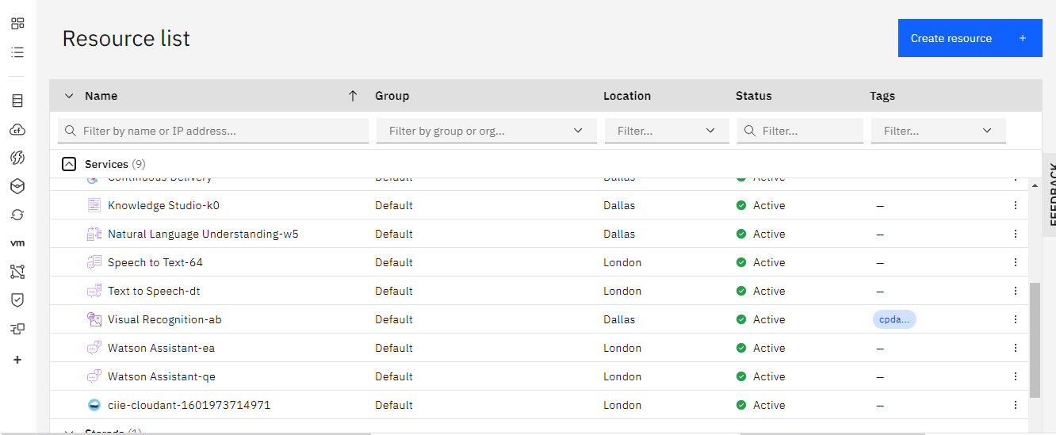
- BUILD A CHAT BOT USING WATSON ASSISTANT
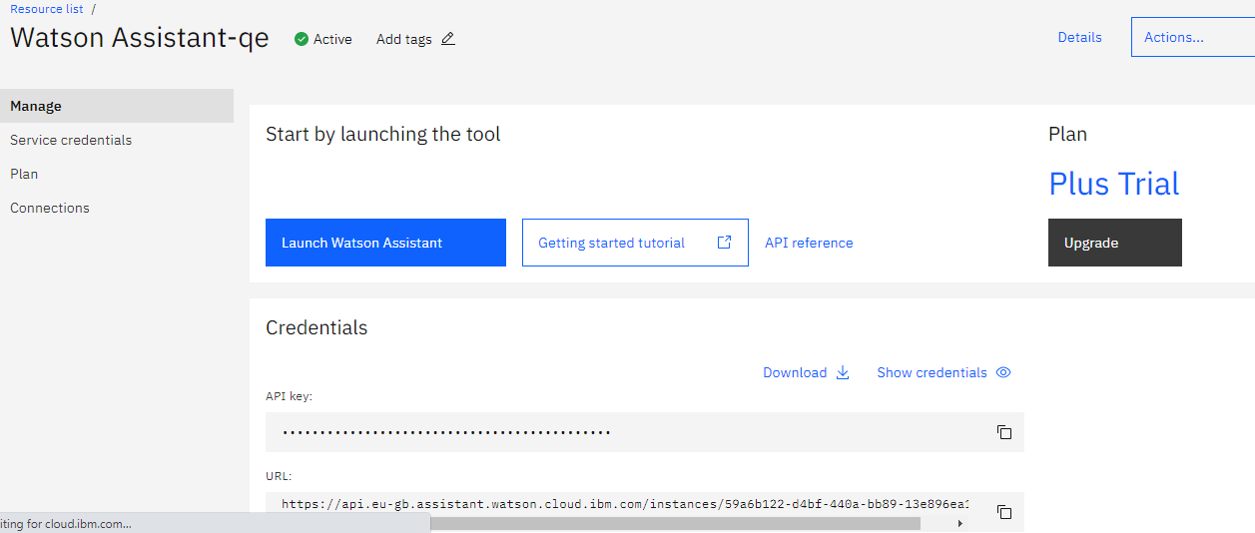
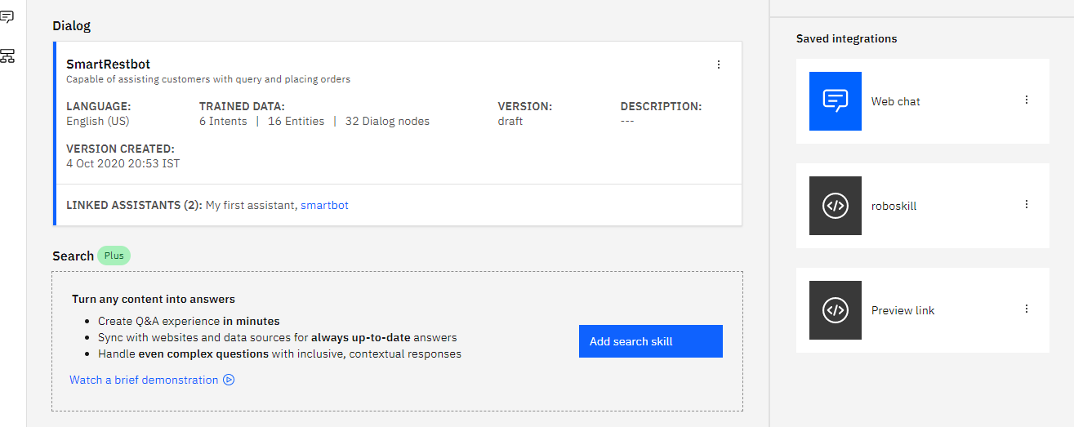
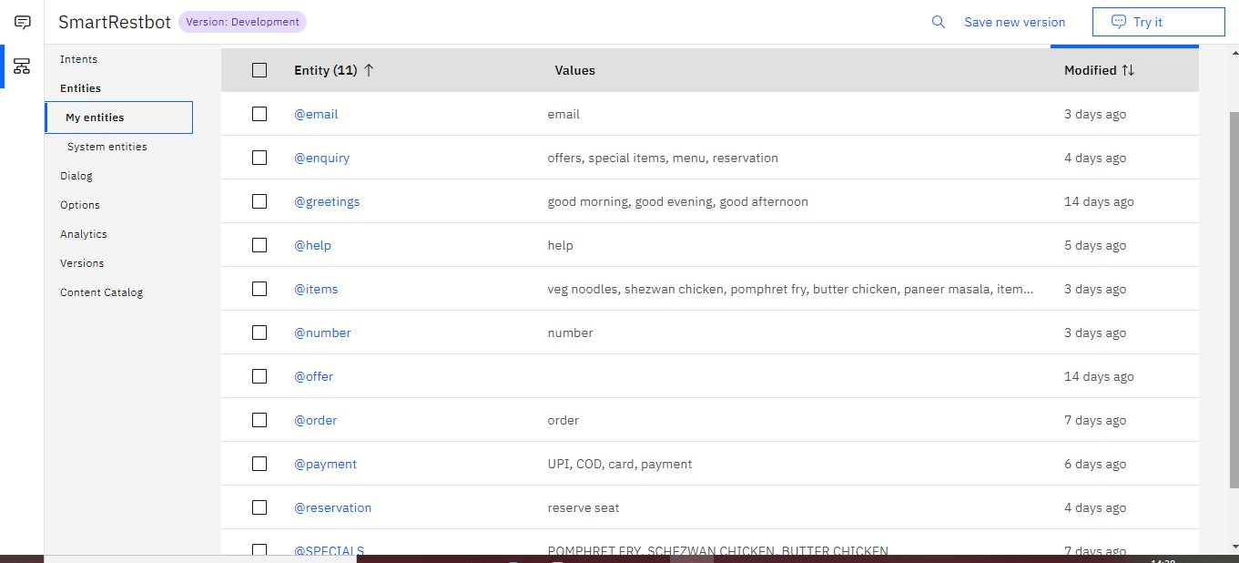
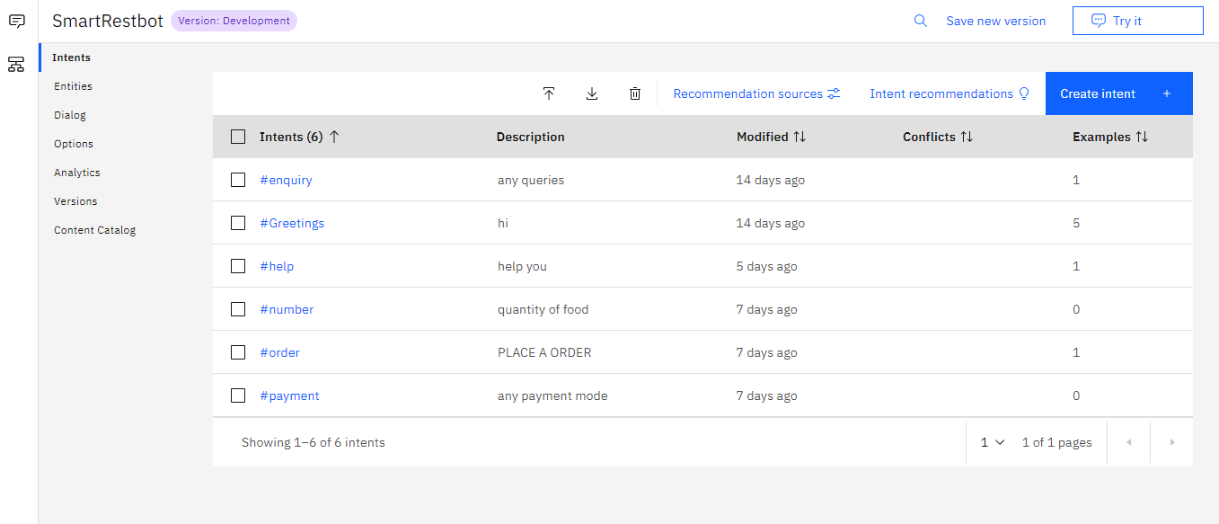
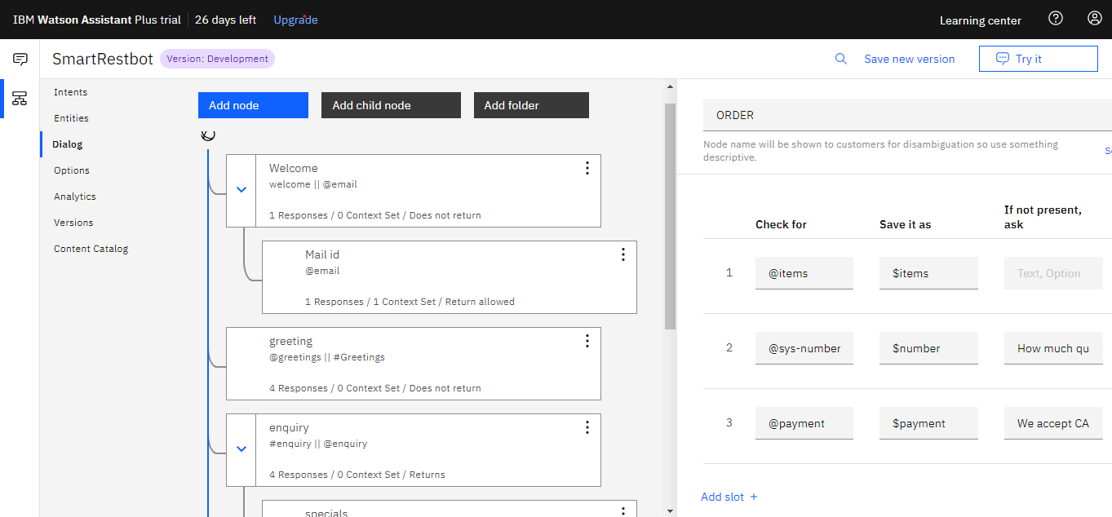
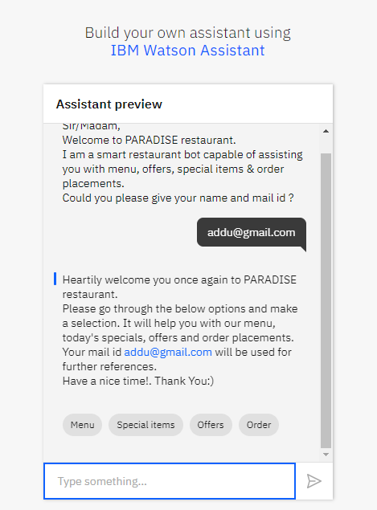
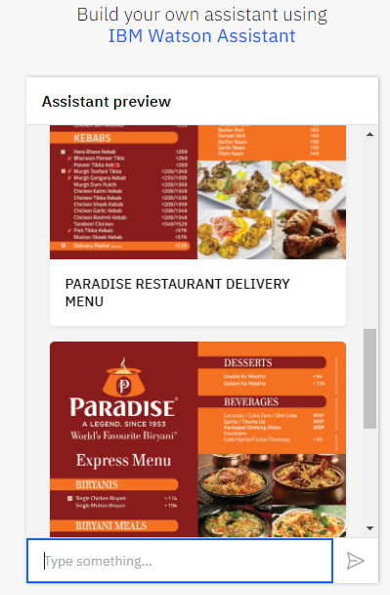
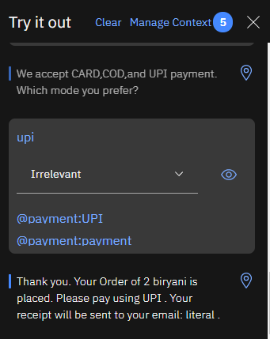
- CREATE A FAST2SMS SERVICE ACCOUNT

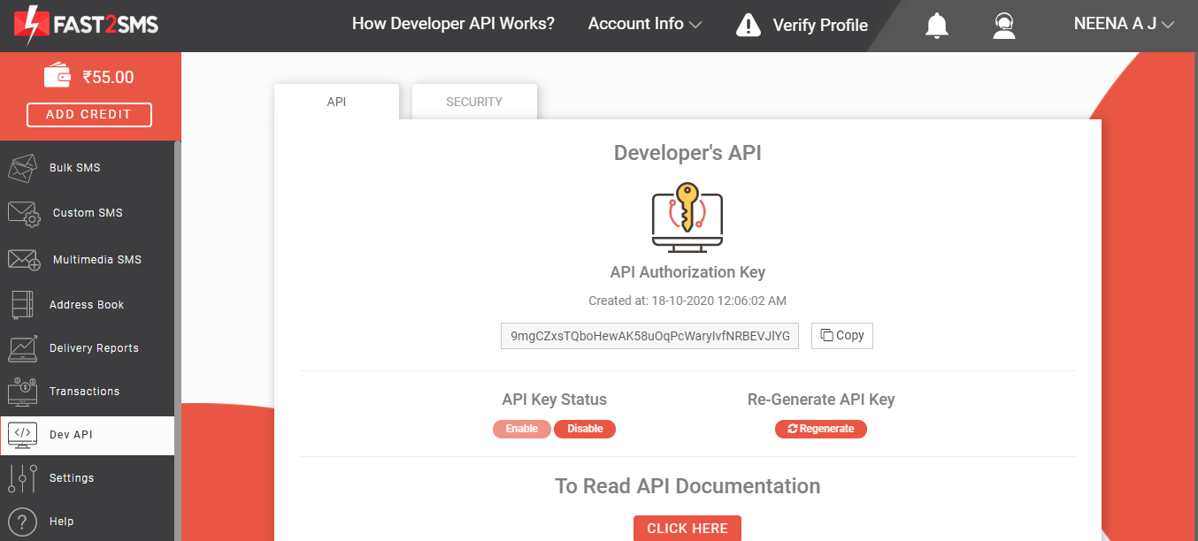

- BUILD NODE RED FLOW AND INTEGRATE WITH WATSON ASSISTANT
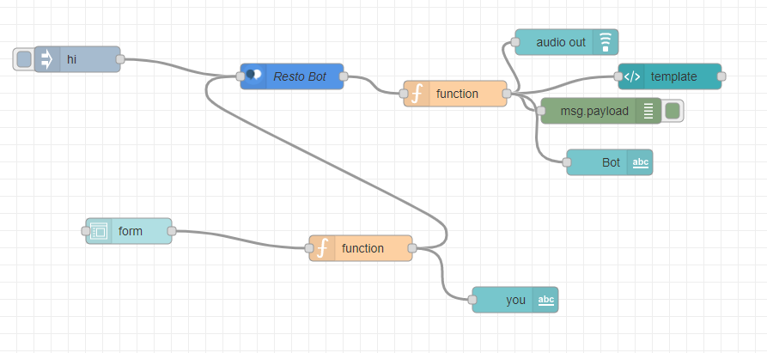
Flow 1: NODE RED FLOW WITHOUT SPEECH TO TEXT INTEGRATION
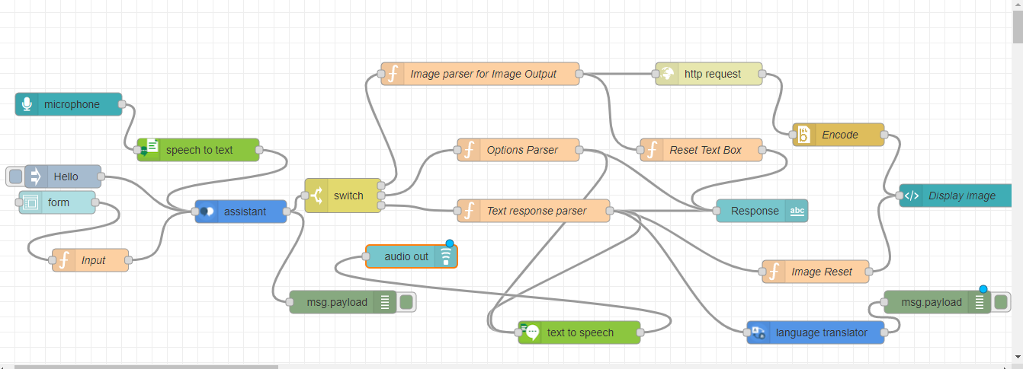
FLOW 2: NODE RED FLOW WITH MICROPHONE AND STT

- FINAL OUTPUT BASED ON NODE RED FLOW ABOVE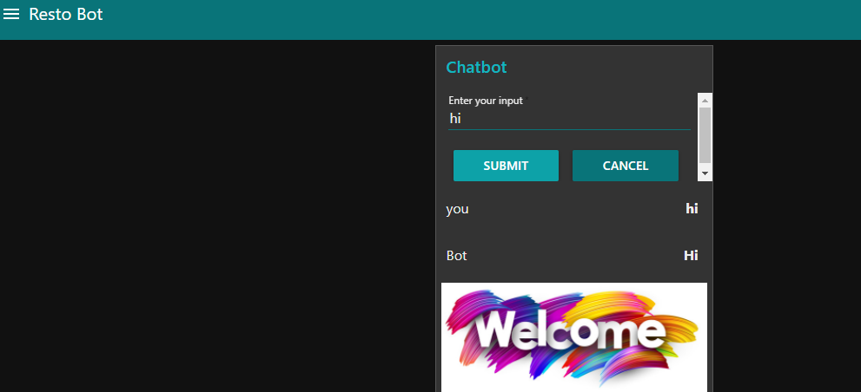
Figure 1: OUTPUT OF FLOW 1 UI WITHOUT STT
- 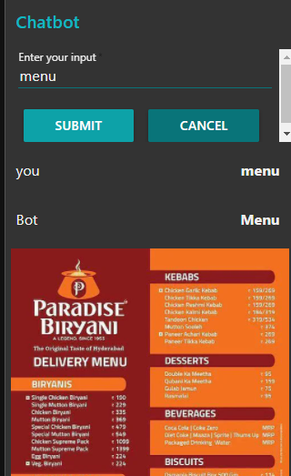
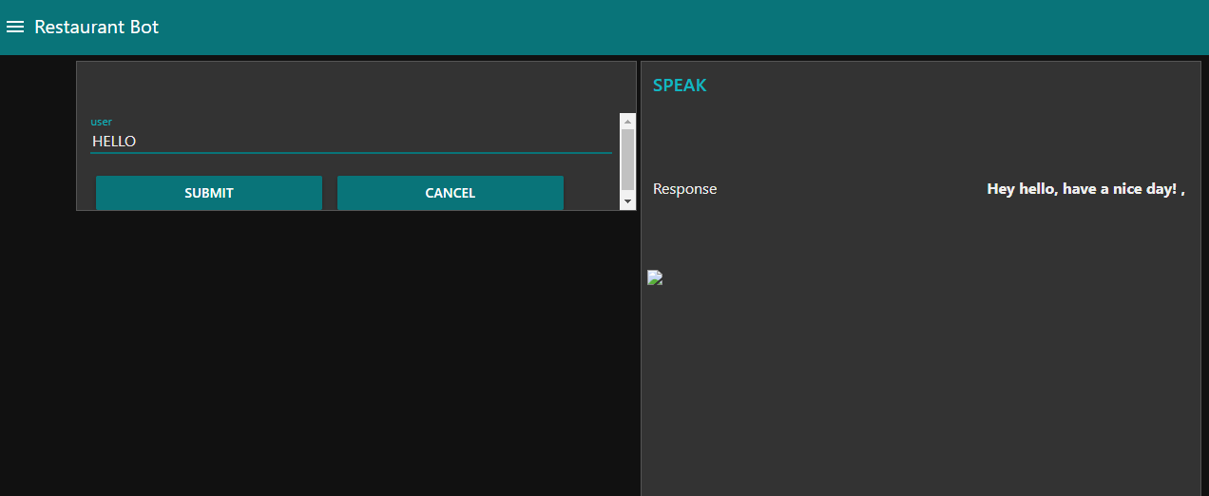
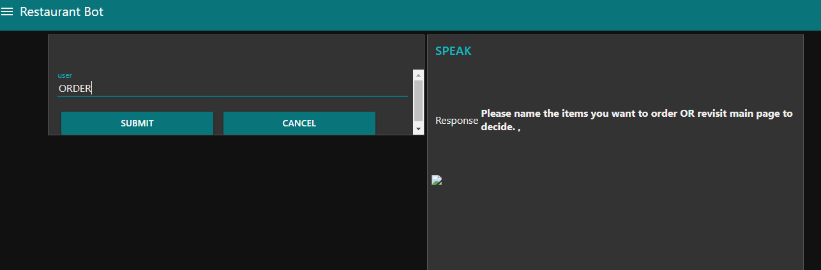
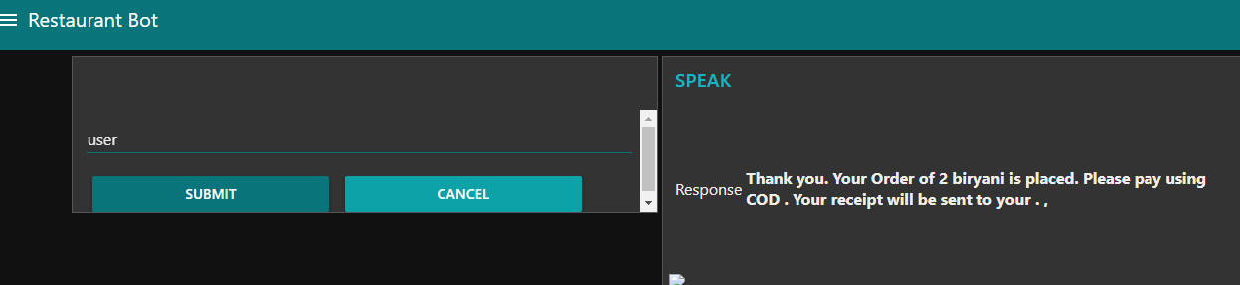
Figure 2: OUTPUT OF FLOW 2 WITH STT

6.CONCLUSION & FUTURE SCOPE
The chatbot built using Watson assistant is able to greet the customer, interpret dialogues and facilitates translation to many languages too .The scope of the project is met.
The future scope of the project involves integration with fast2sms service by embedding a node to activate this service in node red app

APPENDIX
The source codes and other files are uploaded in the github repository
https://github.com/SmartPracticeschool/SPS-6107-Smart-Restaurant-Bot

